**FRIDAY, APRIL 14, 2017, 7:00-9:30 PM  
at the Marbletown Community Center**

**Free Class Sponsored by**

**The Rondout Valley Holistic Health Community,**

**The Morty and Gloria Wolosoff Foundation and**



**Listening: A Path to Peace**

**with Andrew Forsthoefel**

author, transcontinental walker, and peace activist

Listening is not a natural function that everyone was born with, nor a rare, God-given talent. It is, in fact, an artful skill that must be learned by continuous committed practice.

**Without earnest, faithful listening practiced by the individual and the collective, there can be no penetrating understanding of self, other, and everything that flows between the two: no meaningful progress, no true healing, no balance, no peace.**

In this workshop, we will labor together to listen our way into a new world built by trust and true connection, using a combination of storytelling, discussion, dyad and group exercises, and guided meditation.

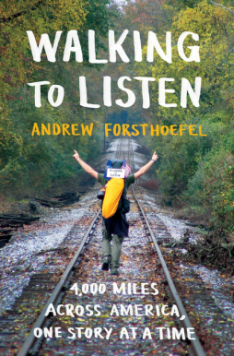

*Andrew Forsthoefel is an author, speaker, and peace activist living in the Pioneer Valley of western Massachusetts. After graduating from Middlebury College in 2011, he spent eleven months walking across the United States, recording interviews with the people he met along the way. He co-produced a radio documentary about his walk that was featured on* This American Life*, and his book,* Walking to Listen *(Bloomsbury, 2017), tells the full tale of his journey. He teaches walking and listening as practices in connective presence, personal transformation, and conflict resolution. Visit him at livingtolisten.com.*